**B.TECH. (2020-24)**

**Artificial Intelligence**

**LAB FILE**

on

**Artificial Intelligence**

**[CSe401]**

Submitted To

**Mr. Soumya Ranjan Nayak**

Submitted By

**DEVANSHU KUMAR SINGh**

**A023119820024**

**4CSE11 (AI)**

DEPARTMENT OF COMPUTER SCIENCE AND ENGINEERING

AMITY SCHOOL OF ENGINEERING AND TECHNOLOGY

AMITY UNIVERSITY UTTAR PRADESH

NOIDA (U.P)

**Experiment 1**

**Aim**

Write a program to implement A* algorithm in python

**Program**

|  |
| --- |
| import numpy as np  import cv2  mazeName = "maze1"  fileType = "png"  maze = cv2.imread(f"./mazes/{mazeName}.{fileType}")[:, :, 0]  bounds = maze.shape  goal = [4,6]  start = [bounds[0]-1, 0]  stlessStart = [bounds[0]-1, 0]  path = []  visited = [] # will contain tuples of traversed coordinates  x = 0  y = 1  def distance(coords, goal):  '''  Returns distance between a node and the goal node  '''  euDist = ((coords[x]-goal[x])**2 + (coords[y]-goal[y])**2)**0.5  return euDist  def moveGen(coords, bounds):  '''  Returns a list of possible blocks to move to  '''  gen = []  moves = [  [1,0],  [-1,0],  [0,1],  [0,-1]  ]  for i in range(4):  X = moves[i][x]  Y = moves[i][y]  new = [coords[x] + X, coords[y] + Y]  if 0 <= new[x] < bounds[x] and 0 <= new[y] < bounds[y] and maze[new[x], new[y]] == 255:  gen.append(new)  return gen  # getting the path  while True:  gen = moveGen(start, bounds)  dist = np.inf  next = []  # getting the next block  for i in gen:  if i not in visited:  if distance(i, goal) < dist:  dist = distance(i, goal)  next = i  if next == goal:  break  else:  visited.append(start)  start = next  path.append(start)  # completing the maze image  maze = cv2.imread(f"./mazes/{mazeName}.{fileType}")  # defining the goal block color  maze[:, :, 2][goal[x], goal[y]] = 15  maze[:, :, 0][goal[x], goal[y]] = 15  # defining the start block color  maze[:, :, 0][stlessStart[x], stlessStart[y]] = 100  maze[:, :, 1][stlessStart[x], stlessStart[y]] = 15  for i in path:  maze[:, :, 2][i[x], i[y]] = 150  cv2.imwrite(f"./mazes/{mazeName}Answer.png", maze) |

**Output**

Problem Maze (Left), Solution Maze (Right)

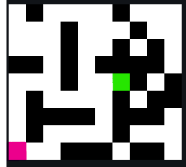 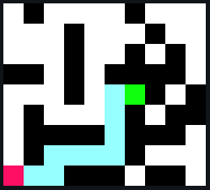

**Experiment 2**

**Aim**

Write a program to implement Single Player Game

**Program**

|  |
| --- |
| import gym  import numpy as np  env = gym.make("CartPole-v0")  def Qtable(state_vars, actions, bin_size=30):  '''  Routine that returns a Q-Table and bin values of each state for the environment  '''  bins = [  np.linspace(-4.8, 4.8, bin_size),  np.linspace(-3, 3, bin_size),  np.linspace(-0.418, 0.418, bin_size),  np.linspace(-3, 3, bin_size),  ]  q_table = np.random.uniform(low=-1, high=1, size=([bin_size]*state_vars + [actions]))  return q_table, bins  def Discrete(state, bins):  '''  Routine that discretizes a state according to the Q-Table  '''  index = []  for i in range(len(state)):  index.append(np.digitize(state[i], bins[i]) - 1)  return tuple(index)  # creating a qtable  qTable, bins = Qtable(  len(env.observation_space.low), # or .high, doesn't really matter  env.action_space.n  )  def Q(qTable, bins, episodes=5000, gamma=0.95, eta=0.1, timestep=1000, epsilon=0.15):  rewards = 0  steps = 0  runs = [0]  data = {'max': [0], 'avg': [0]}  solved = False  for episode in range(1, episodes+1):  currentState = Discrete(env.reset(), bins)  score = 0  done = False  while not done:  steps += 1  if episode%episodes == 0:  env.render()  # checking to see whether to explore or exploit  if np.random.uniform(0,1) < epsilon:  action = env.action_space.sample()  else:  action = np.argmax(qTable[currentState])  # getting new state  obs, reward, done, _ = env.step(action)  newState = Discrete(obs, bins)  # increasing the reward  score += reward    # updating the Qtable  if not done:  maxFutureQ = np.max(qTable[newState])  currentQ = qTable[currentState + (action,)]  newQ = (1-eta)*currentQ + eta*(reward + gamma*maxFutureQ)  qTable[currentState + (action,)] = newQ  currentState = newState  else:  rewards += score  runs.append(score)  if score > 195 and steps >= 100 and solved == False: # considered as a solved:  solved = True  print('Solved in episode : {}'.format(episode))    # Timestep value update  if episode % timestep == 0:  print('Episode : {} | Reward -> {} | Max reward : {}'.format(episode,rewards/timestep, max(runs)))  data['max'].append(max(runs))  data['avg'].append(rewards/timestep)  if rewards/timestep >= 195:  print('Solved in episode : {}'.format(episode))  rewards, runs= 0, [0]  q_table, bins = Qtable(len(env.observation_space.low), env.action_space.n, bin_size=25)  Q(q_table, bins, eta=0.15, gamma=0.995, episodes=5*10**3, timestep=1000) |

**Output**

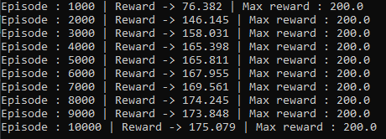

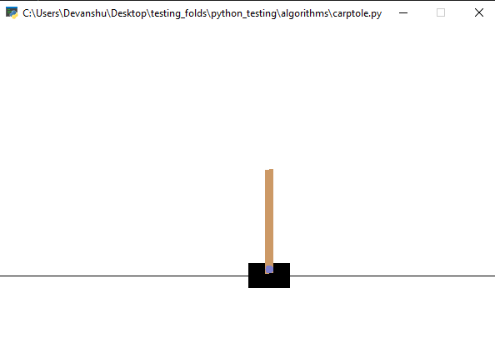

**Experiment 3**

**Aim**

Write a program to implement Tic-Tac-Toe game problem

**Program**

|  |
| --- |
| import os  from tabnanny import check  # Python3 program to find the next optimal move for a player  player, opponent = 'x', 'o'  # This function returns true if there are moves  # remaining on the board. It returns false if  # there are no moves left to play.  def isMovesLeft(board) :  for i in range(3) :  for j in range(3) :  if (board[i][j] == '_') :  return True  return False  def evaluate(b) :  # Checking for Rows for X or O victory.  for row in range(3) :  if (b[row][0] == b[row][1] and b[row][1] == b[row][2]) :  if (b[row][0] == player) :  return 10  elif (b[row][0] == opponent) :  return -10  # Checking for Columns for X or O victory.  for col in range(3) :    if (b[0][col] == b[1][col] and b[1][col] == b[2][col]) :    if (b[0][col] == player) :  return 10  elif (b[0][col] == opponent) :  return -10  # Checking for Diagonals for X or O victory.  if (b[0][0] == b[1][1] and b[1][1] == b[2][2]) :    if (b[0][0] == player) :  return 10  elif (b[0][0] == opponent) :  return -10  if (b[0][2] == b[1][1] and b[1][1] == b[2][0]) :    if (b[0][2] == player) :  return 10  elif (b[0][2] == opponent) :  return -10  # Else if none of them have won then return 0  return 0  # This is the minimax function. It considers all  # the possible ways the game can go and returns  # the value of the board  def minimax(board, depth, isMax) :  score = evaluate(board)  # If Maximizer has won the game return his/her  # evaluated score  if (score == 10) :  return score  # If Minimizer has won the game return his/her  # evaluated score  if (score == -10) :  return score  # If there are no more moves and no winner then  # it is a tie  if (isMovesLeft(board) == False) :  return 0  # If this maximizer's move  if (isMax) :  best = -1000  # Traverse all cells  for i in range(3) :  for j in range(3) :    # Check if cell is empty  if (board[i][j]=='_') :    # Make the move  board[i][j] = opponent  # Call minimax recursively and choose  # the maximum value  best = max( best, minimax(board,  depth + 1,  not isMax) )  # Undo the move  board[i][j] = '_'  return best  # If this minimizer's move  else :  best = 1000  # Traverse all cells  for i in range(3) :  for j in range(3) :    # Check if cell is empty  if (board[i][j] == '_') :    # Make the move  board[i][j] = player  # Call minimax recursively and choose  # the minimum value  best = min(best, minimax(board, depth + 1, not isMax))  # Undo the move  board[i][j] = '_'  return best  # This will return the best possible move for the player  def findBestMove(board) :  bestVal = -1000  bestMove = (-1, -1)  # Traverse all cells, evaluate minimax function for  # all empty cells. And return the cell with optimal  # value.  for i in range(3) :  for j in range(3) :    # Check if cell is empty  if (board[i][j] == '_') :    # Make the move  board[i][j] = opponent  # compute evaluation function for this  # move.  moveVal = minimax(board, 0, False)  # Undo the move  board[i][j] = '_'  # If the value of the current move is  # more than the best value, then update  # best/  if (moveVal > bestVal) :  bestMove = (i, j)  bestVal = moveVal  print("The value of the best Move is :", bestVal)  print()  return bestMove  def checkWin(board):  for r in board:  if r == ['o','o','o']:  return 1  if r == ['x','x','x']:  return 0  for i in range(len(board)):  c = []  for j in range(len(board)):  c.append(board[j][i])    if c == ['o','o','o']:  return 1  if c == ['x','x','x']:  return 0    if [board[0][0], board[1][1], board[2][2]] == ['o','o','o']:  return 1  if [board[0][0], board[1][1], board[2][2]] == ['x','x','x']:  return 0  if [board[0][2], board[1][1], board[2][0]] == ['o','o','o']:  return 1  if [board[0][2], board[1][1], board[2][0]] == ['x','x','x']:  return 0  def printBoard(board):  for i in board:  for j in i:  print(j, end=" ")  print("\n")  # Driver code  board = [  [ '_', '_', '_' ],  [ '_', '_', '_' ],  [ '_', '_', '_' ]  ]  bestMove = findBestMove(board)  print("The Optimal Move is :")  print("ROW:", bestMove[0], " COL:", bestMove[1])  win = False  draw = False  while not (win or draw):  printBoard(board)  print()  bestMove = findBestMove(board)  board[bestMove[0]][bestMove[1]] = 'o'  if checkWin(board) == 1:  print('cpu wins!')  win = True  break    r = int(input("enter your move (r) : "))  c = int(input("enter your move (c) : "))  board[r-1][c-1] = 'x'  if checkWin(board) == 0:  print('player wins!')  win = True  break    if checkWin(board) != 1 or checkWin(board) != 0:  print("drawwww!!!") |

**Output**

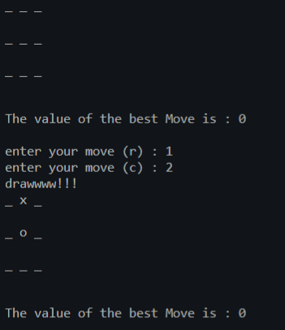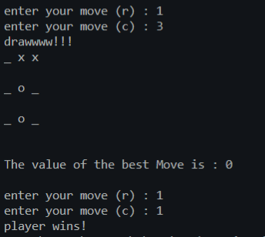

**Experiment 4**

**Aim**

Implement Brute force solution to the Knapsack problem in Python

**Program**

|  |
| --- |
| def knapSack(W, wt, val, n):  # initial conditions  if n == 0 or W == 0 :  return 0  # If weight is higher than capacity then it is not included  if (wt[n-1] > W):  return knapSack(W, wt, val, n-1)  # return either nth item being included or not  else:  return max(val[n-1] + knapSack(W-wt[n-1], wt, val, n-1),  knapSack(W, wt, val, n-1))  val = [60, 100, 120]  wt = [10, 20, 30]  W = 50  n = len(val)  print (knapSack(W, wt, val, n)) |

**Output**



**Experiment 5**

**Aim**

Implement Graph colouring problem using python

**Program**

|  |
| --- |
| import networkx as nx  # creating the graph  network = nx.Graph()  # adding nodes  network.add_nodes_from([4,5,6,7])  network.add_edge(1,4)  network.add_edge(1,5)  network.add_edge(2,4)  network.add_edge(3,5)  network.add_edge(5,6)  network.add_edge(7,3)  network.add_edge(7,6)  # defining color list  color_list = ["gold", "violet", "violet", "violet",  "limegreen", "limegreen", "darkorange"]  # final colored graph  nx.draw_networkx(network,node_color=color_list, with_labels=True) |

**Output**

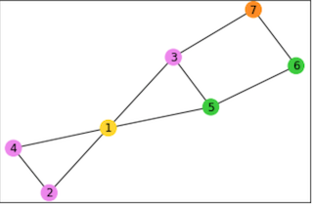

**Experiment 6**

**Aim**

Write a program to implement BFS for water jug problem using Python

**Program**

|  |
| --- |
| x_capacity = int(input("Enter Jug 1 capacity:"))  y_capacity = int(input("Enter Jug 2 capacity:"))  end = int(input("Enter target volume:"))  def bfs(start, end, x_capacity, y_capacity):  path = []  front = []  front.append(start)  visited = []  #visited.append(start)  while(not (not front)):  current = front.pop()  x = current[0]  y = current[1]  path.append(current)  if x == end or y == end:  print("Found!")  return path  # rule 1  if current[0] < x_capacity and ([x_capacity, current[1]] not in visited):  front.append([x_capacity, current[1]])  visited.append([x_capacity, current[1]])  # rule 2  if current[1] < y_capacity and ([current[0], y_capacity] not in visited):  front.append([current[0], y_capacity])  visited.append([current[0], y_capacity])  # rule 3  if current[0] > x_capacity and ([0, current[1]] not in visited):  front.append([0, current[1]])  visited.append([0, current[1]])  # rule 4  if current[1] > y_capacity and ([x_capacity, 0] not in visited):  front.append([x_capacity, 0])  visited.append([x_capacity, 0])  # rule 5  #(x, y) -> (min(x + y, x_capacity), max(0, x + y - x_capacity)) if y > 0  if current[1] > 0 and ([min(x + y, x_capacity), max(0, x + y - x_capacity)] not in visited):  front.append([min(x + y, x_capacity), max(0, x + y - x_capacity)])  visited.append([min(x + y, x_capacity), max(0, x + y - x_capacity)])  # rule 6  # (x, y) -> (max(0, x + y - y_capacity), min(x + y, y_capacity)) if x > 0  if current[0] > 0 and ([max(0, x + y - y_capacity), min(x + y, y_capacity)] not in visited):  front.append([max(0, x + y - y_capacity), min(x + y, y_capacity)])  visited.append([max(0, x + y - y_capacity), min(x + y, y_capacity)])  return "Not found"  def gcd(a, b):  if a == 0:  return b  return gcd(b%a, a)  # start state: x = 0 , y = 0  start = [0, 0]  #end = 2  #x_capacity = 4  #y_capacity = 3  # condition for getting a solution:  # the target volume 'end' should be a multiple of gcd(a,b)  if end % gcd(x_capacity,y_capacity) == 0:  print(bfs(start, end, x_capacity, y_capacity))  else:  print("No solution possible for this combination.")  input() |

**Output**

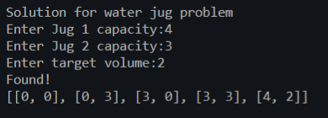

**Experiment 7**

**Aim**

Write a program to implement DFS using Python

**Program**

|  |
| --- |
| NodeData = {  "A": ["B", "C"],  "B": ["D", "E", "A"],  "C": ["F", "G", "A"],  "D": ["B"],  "E": ["B", "F"],  "F": ["C", "H", "E"],  "G": ["C"],  "H": ["F"]  } |
| # WHEN NodeData WAS KEPT IN A SEPARATE FILE, IMPORT  from jsonNodeData import NodeData  # CLASS FOR NODE OBJECT  class Node:  def __init__(self, data, children) -> None:  self.data = data  self.children = children  nodes = []  # ADDING NODES TO THE GRAPH  for node in NodeData:  new = None  if NodeData[node]:  new = Node(  data=node,  children=NodeData[node]  )  else:  new = Node(  data=node,  children=None  )  nodes.append(new)  open = nodes  waiting = [None]  visited = []  # TERMINATION DATA  start = input("Enter start node: ").upper()  goal = input("Enter end node: ").upper()  currentNode = Node(data=None, children=None) #PLACEHOLDER NODE  # CHECKING IF START NODE EXISTS  if start not in NodeData:  print("Start node doesn't exist")  exit  # GET THE NEW NODE TO WORK WITH  for node in open:  if node.data == start:  waiting.append(node)  open.remove(node)  # TRAVERSING THE GRAPH  while currentNode:  if currentNode.data == goal:  # insert at top  visited.append(currentNode)  break  else:  # ADDING THE CURRENT NODE TO THE VISITED STACK  visited.append(currentNode)  # NOW ADDING CHILDREN OF CURRENTNODE  # TO WAITING  if currentNode.children:  for child in currentNode.children:  for node in open:  if node.data == child:  waiting.append(node)  open.remove(node)  currentNode = waiting.pop()  # REMOVING THE PLACEHOLDER NODE  visited = visited[1:]  # ROUTINE TO CHECK IF AN ARRAY CONTAINS  # ANY OF ITS ELEMENTS IN ANOTHER ARRAY  def subCheck(arr1, arr2):  flag = False  for i in arr1:  if i in arr2:  flag = True  return flag  # ROUTINE TO REMOVE NODE FROM AN ARRAY  # RETURNS THE NEW ARRAY  def removeNode(node, array):  for n in array:  if node.data == n.data:  array.remove(node)  return array  # TRACING BACK THE PATH FROM START NODE TO GOAL NODE  visitedCopy = visited[:]  for i in range(len(visitedCopy)):  node = visitedCopy[i]  subVisitedData = [chnode.data for chnode in visitedCopy[i+1:]]  if not subCheck(node.children, subVisitedData):  if node.data != goal:  visited = removeNode(node, visited)  if visited[-1].data == goal:  print("Goal node reached!")  # THE PATH FROM START NODE TO GOAL NODE  for node in visited:  print(node.data)  else:  print("Goal doesn't exist.") |

**Output**

Problem graph (Left), Solution paths (Right)

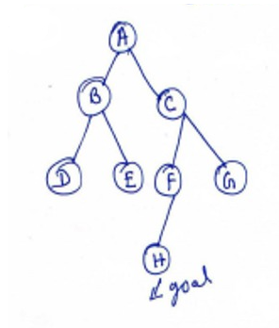 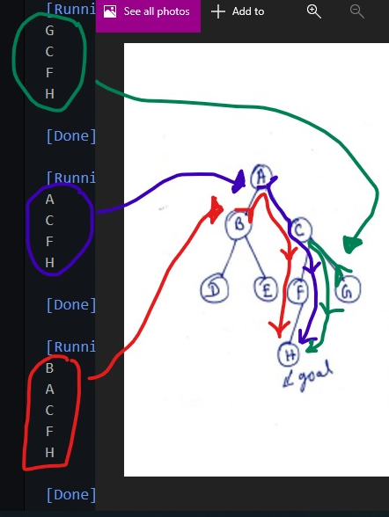

**Experiment 8**

**Aim**

Tokenization of word and Sentences with the help of NLTK package

**Program**

|  |
| --- |
| from nltk.tokenize import word_tokenize  s = "Good muffins cost $3.88 in New York. Please buy me two of them. Thanks."  Word_tokenize(s) |

**Output**

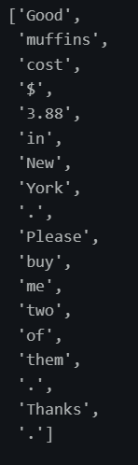

**Experiment 9**

**Aim**

Design an XOR truth table using Python

**Program**

|  |
| --- |
| def XOR (a, b):  if a != b:  return 1  else:  return 0  print(" A = False, B = False | A XOR B =",XOR(False,False)," | ")  print(" A = False, B = True | A XOR B =",XOR(False,True)," | ")  print(" A = True, B = False | A XOR B =",XOR(True,False)," | ")  print(" A = True, B = True | A XOR B =",XOR(True,True)," | ") |

**Output**

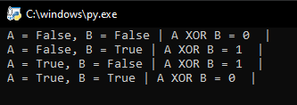

**Experiment 10**

**Aim**

Study of scikit fuzzy

**Program**

|  |
| --- |
| import numpy as np  import skfuzzy.control as ctrl  universe = np.linspace(-2, 2, 5)  error = ctrl.Antecedent(universe, 'error')  delta = ctrl.Antecedent(universe, 'delta')  output = ctrl.Consequent(universe, 'output')  names = ['nb', 'ns', 'ze', 'ps', 'pb']  error.automf(names=names)  delta.automf(names=names)  output.automf(names=names)  rule0 = ctrl.Rule(antecedent=((error['nb'] & delta['nb']) |  (error['ns'] & delta['nb']) |  (error['nb'] & delta['ns'])),  consequent=output['nb'], label='rule nb')  rule1 = ctrl.Rule(antecedent=((error['nb'] & delta['ze']) |  (error['nb'] & delta['ps']) |  (error['ns'] & delta['ns']) |  (error['ns'] & delta['ze']) |  (error['ze'] & delta['ns']) |  (error['ze'] & delta['nb']) |  (error['ps'] & delta['nb'])),  consequent=output['ns'], label='rule ns')  rule2 = ctrl.Rule(antecedent=((error['nb'] & delta['pb']) |  (error['ns'] & delta['ps']) |  (error['ze'] & delta['ze']) |  (error['ps'] & delta['ns']) |  (error['pb'] & delta['nb'])),  consequent=output['ze'], label='rule ze')  rule3 = ctrl.Rule(antecedent=((error['ns'] & delta['pb']) |  (error['ze'] & delta['pb']) |  (error['ze'] & delta['ps']) |  (error['ps'] & delta['ps']) |  (error['ps'] & delta['ze']) |  (error['pb'] & delta['ze']) |  (error['pb'] & delta['ns'])),  consequent=output['ps'], label='rule ps')  rule4 = ctrl.Rule(antecedent=((error['ps'] & delta['pb']) |  (error['pb'] & delta['pb']) |  (error['pb'] & delta['ps'])),  consequent=output['pb'], label='rule pb')  upsampled = np.linspace(-2, 2, 21)  x, y = np.meshgrid(upsampled, upsampled)  z = np.zeros_like(x)  for i in range(21):  for j in range(21):  sim.input['error'] = x[i, j]  sim.input['delta'] = y[i, j]  sim.compute()  z[i, j] = sim.output['output']  import matplotlib.pyplot as plt  from mpl_toolkits.mplot3d import Axes3D  fig = plt.figure(figsize=(8, 8))  ax = fig.add_subplot(111, projection='3d')  surf = ax.plot_surface(x, y, z, rstride=1, cstride=1, cmap='viridis',  linewidth=0.4, antialiased=True)  cset = ax.contourf(x, y, z, zdir='z', offset=-2.5, cmap='viridis', alpha=0.5)  cset = ax.contourf(x, y, z, zdir='x', offset=3, cmap='viridis', alpha=0.5)  cset = ax.contourf(x, y, z, zdir='y', offset=3, cmap='viridis', alpha=0.5)  ax.view_init(30, 200) |

**Output**

